Official league roster - Soccer
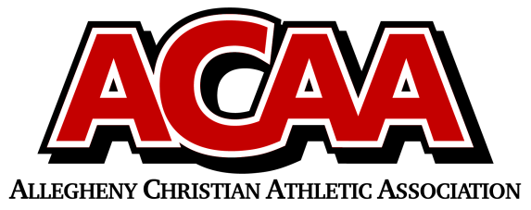

School Name: Great Commission
Team Colors: Blue and White
Overall Wins ___ Losses ____ Ties ___
ACAA Wins ___ Losses ____ Ties ___ OPPONENT: __________________________
Date: _________
Number | Name | Year | Position | Homeschool
1 | Samuel Higgins | 12 | Keeper
13 | Isaac Moore | 12 | Striker
10 | Luke Fleck | 11 | striker
15 | Liam Gibbons | 11 | Defender
17 | Hunter Hatch | 11 | Midfield
16 | Daniel Replogle | 11 | Defender
20 | Charlie Lohsl | 11 | Forward
11 | Landyn Summer | 10 | MIDFIELD
2 | Jakson Moore | 10 | DEFENDER
12 | Elijah Michael | 10 | MID/STRIKER
14/35(K) | Alex Guise | 9 | MID/KEEPER
3 | Peyton Hicks | 9 | STRIKER
4 | Daniel Kurty | 9 | DEFENDER
9 | Andrew Haire | 8 | FORWARD
21 | Wesley Hicks | 8 | FORWARD
5 | Aaron Kurty | 8 | FORWARD
8 | Grant Michael | 8 | MID/DEFENDER
6 | Van Nachtman | 8 | MID/STRIKER | YES
7 | Zacariah Best | 7 | FORWARD

Head Coach: Scott hildebrand
Asst. coach: Josh Long
Asst. coach:

Official ACAA League Team Roster. to be submitted to the scorer’s table before each game.

